ATTENTION SHOPPERS!

The 2017 VACVB (VADMO)Tourism Symposium

Silent Auction!
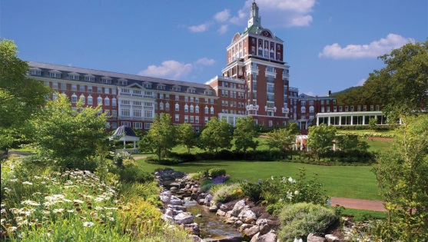
At The Omni Homestead Resort, April 2-4, 2017
We need YOUR help!
The VACVB (VADMO) Tourism Symposium will hold a Silent Auction to benefit the VACVB (VADMO) and we are seeking the donations of gifts, services, mini-vacations, accommodations, tickets to performances….whatever might be of interest to attendees to this great educational event being held the beginning of April!
If you have a donation(s) for this Silent Auction, please either bring it to The VACVB Tourism Symposium (please read details below) or mail it in advance to arrive no later than March 27, 2017 to the following address: Sergei Troubetzkoy, Lynchburg Regional CVB – Silent Auction, 901 Church Street, Lynchburg, VA 24504.
QUESTIONS? – Contact Sergei at: (434) 485.7297 or Sergei.troubetzkoy@lynchburgva.gov
If bringing or shipping your donation, please provide in advance a brief description of the item, a Value for that item and the name of the individual or company donating that item. We need this information in advance in order to know how much display space to prepare and we will send out in advance a list of available items since those not attending the symposium may submit absentee bids!
Thanks for your support!

