VACVB
PO Box 3363
Warrenton, VA 20188
(P) (540) 904-4710
(F) (202) 962-3939
vacvb@colliegorg.com
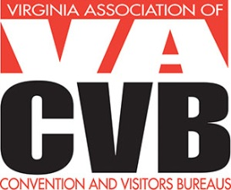
The VIRGO Travel & Tourism Awards Program is organized by the Virginia Association of Convention and Visitors Bureaus (VACVB) and is open to individuals, businesses, organizations or other entities located in the Commonwealth of Virginia. The program is open to VACVB members and non-members. Entries must have been produced between January 1, 2015 and December 31, 2015. All entries must be submitted electronically using the form on www.VACVB.com. Entries will be submitted for judging once payment is made.

>Title of the entry: ____________________________________________________________

>Title of the entry: ____________________________________________________________

(Additional titles may be listed on the rear of this form.)

Contact Name: __________________________________ Organization: _________________

Email: __________________________________ Phone ( ) ________________________

2016 Virgo Nominations Fees
First Three entries: VACVB Member $35 each | Non Members $50 each
Fourth entry (plus): VACVB Member $25 each | Non-members $40 each

Credit Card Payment
Credit Card: VISA ____ MasterCard ____ AMEX ____

Name on Credit Card __________________________________________________
Credit Card # ________________________________________________________
Expiration Date ________________ 3 or 4 Digit CVV Code ___________________

Amount Authorized $_________________
Signature ___________________________________________________________
Date ______________________________

Checks should be made payable to VACVB (Federal ID #54-1788339) and sent to:
PO Box 3363, Warrenton, VA 20188

