VACVB  PO Box 3363  Warrenton, VA 20188  (P) (540) 904-4710  (F) (202) 962-3939  vacvb@colliegorg.com  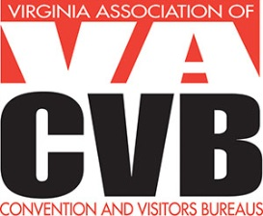 | dATE iNVOICE #  5/4/2014 2014 - 101  Invoice

Contact Information

Number of Submissions | DESCRIPTION | AMOUNT
 | 2014 Virgo Nominations –
 | One - $35 | $
 | Two - $70 | $
 | Three - $105 | $
 | Four - $130 | $
Thank you for your continued support of VACVB! TOTAL |  | $

Payment
Credit Card: VISA ____ MasterCard ____ AMEX ____

Name on Credit Card __________________________________________________
Credit Card # ________________________________________________________
Expiration Date ________________ 3 or 4 Digit CVV Code ___________________

Amount Authorized $_________________
Signature ___________________________________________________________
Date ______________________________

Checks should be made payable to VACVB (Federal ID #54-1788339) and sent to:
PO Box 3363, Warrenton, VA 20188

